**Steps to completing the FLORIDA FINANCIAL AID APPLICATION (FFAA)**

**(Bright Futures)**

1. 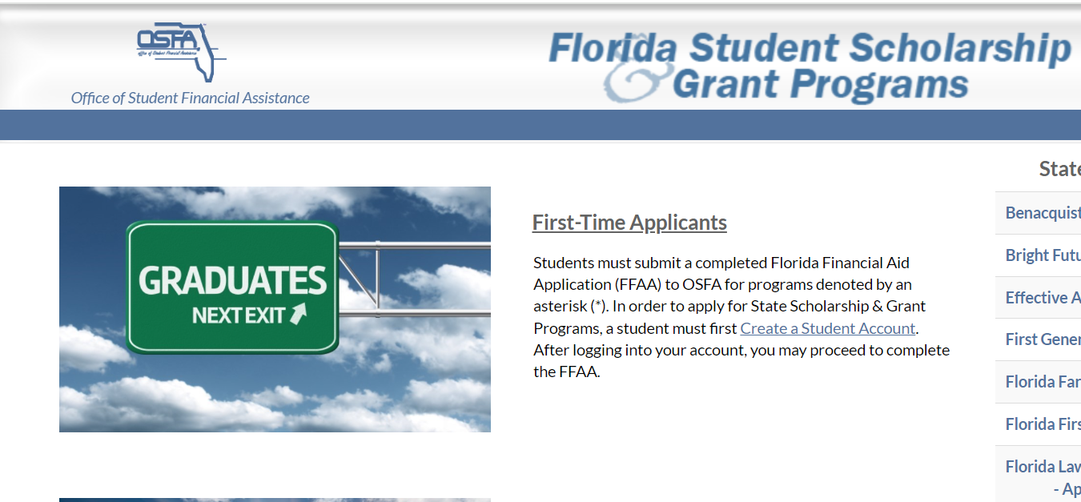**Create an FFAA account-The FFAA determines eligibility for state of Florida grants and scholarships (Florida Bright Futures, First Generation Matching Grant Program, Florida Farmworker Student Scholarship Program)**
2. **Completing the Profile Screen- Information submitted on the Profile screen will be reflected on the FFAA in the Demographic Information section.**

**Note: If a high school graduation date is entered in the HS Graduation Date field outside the current senior year, the student cannot proceed. First-year students, Sophomores and juniors must wait until October 1 of their senior year to complete a Profile and FFAA.**

1. **Complete the Florida Financial Aid Application (FFAA)**

**All students will be required to complete the three tabs listed below:**

**\*Demographic Information * Academic Background * Submit/Acknowledgment**

**Uploading Documents: At the bottom of the FFAA homepage, in the left-hand corner, you will find a tab to upload documents.**

**(**[**https://www.floridastudentfinancialaidsg.org/PDF/BFHandbookChapter1.pdf#page=3**](https://www.floridastudentfinancialaidsg.org/PDF/BFHandbookChapter1.pdf#page=3)**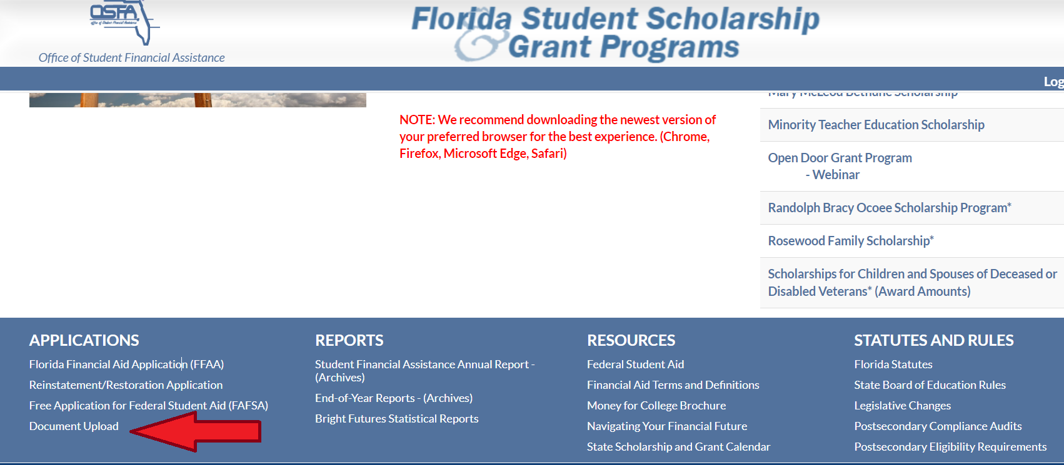)**

**TEST scores: Students should request that test scores be sent to one of Florida’s public colleges or state universities when they register for the ACT® / SAT® so that test scores will be sent to the Florida Department of Education repository. PERT scores are reported on students' official high school transcripts.**

**Note: Students can request single sitting ACT test scores be sent directly to Bright Futures using CEEB code 0095 while on the ACT website.**

**Bright Futures Contact information:**

**Phone: 888-827-2004**

**Email: osfa@fldoe.org**